**Module 4 - Fundamentals of AI**

**Course Number:** EAI 6000

**Academic Term:** Fall 2020 CPS Analytics  
**Instructor’s Name:** Kasun Samarasinghe

**Assignment Completion Date:** 11-22-2020

**Submitted By:**

Dhiren Vasudev Pagrani

Sunil Raj Thota

Shivani Sharma



**INTRODUCTION**

In this report, we will build a network model to predict the outcome of our Mechanism of Action (MOA) using Regression Analysis. Before applying regression analysis on our dataset lets understand the basics of regression analysis and its implications. We will also see how neural networks helps in building model seamless and help predict results with minimal errors,

Regression analysis can assist you with displaying the connection between a dependent variable (which you are attempting to anticipate) and one or more independent variables (the contribution of the model). Regression analysis can show if there is a huge connection between the autonomous factors and the needy variable, and the quality of the effect—when the free factors move, by the amount you can anticipate that the needy variable should move.

The simplest, linear regression equation looks like this:



Where

y - Dependent variable

X2, 3...k - Independent variables

(Beta) 1,2, 3...k - Coefficients

(Error) - Distance between value predicted by the model and the actual dependent variable y

Regression in Neural Networks

Neural organizations are reducible to regression models - a neural organization can "pretend" to be any sort of regression model. For instance, this exceptionally basic neural organization, with just one information neuron, one hidden neuron, and one output neuron, is identical to logistic regression. It takes several dependent factors = input boundaries, multiplies them by their coefficients = weights, and runs them through a sigmoid initiation work and a unit step function, which intently looks like the calculated relapse work with its mistake term.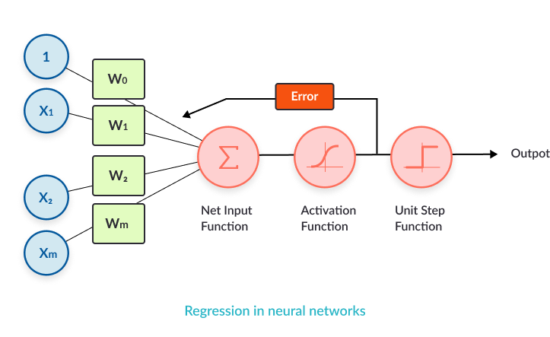

The logistic regression we modeled above is reasonable for binary classification. Imagine a scenario where we have to demonstrate multi-class grouping. We can build the intricacy of the model by utilizing various neurons in the hidden layer, to accomplish one-versus all order. Every order choice can be encoded utilizing three parallel digits.

Pros and Cons using Neural Networks as opposed to other ML models

|  |  |
| --- | --- |
| Pros | Cons |
| * Neural organizations are adaptable and can be utilized for both regression and classification issues. Any information which can be created numeric can be utilized in the model, as a neural organization is a numerical model with approximation capacities. | * Neural networks are black boxes, which means we can't realize how much every autonomous variable is impacting the dependent variables. |
| * Neural networks are acceptable to show with nonlinear information with an enormous number of contributions; for example, pictures. It is solid in a methodology of errands including numerous highlights. It works by parting the issue of characterization into a layered organization of easier components. | * It is computationally over the top expensive and tedious to prepare with customary CPUs. |
| * When prepared, the expectations are pretty quick. | * Neural networks rely a ton upon preparing information. This prompts the issue of over-fitting and speculation. The mode depends more on the preparation information and might be tuned to the information. |
| * Neural organizations can be prepared with quite a few sources of info and layers. |  |
| * Neural organizations work best with more information focuses. |  |

**Analysis**

As a part of assignment this week we did prediction by building a neural network model. Here is the analysis for the same.

Following are the libraries required for the algorithm:

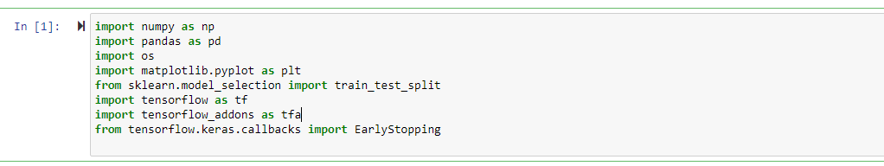

Following is the logic for reading the csv files and storing them in a data frame.

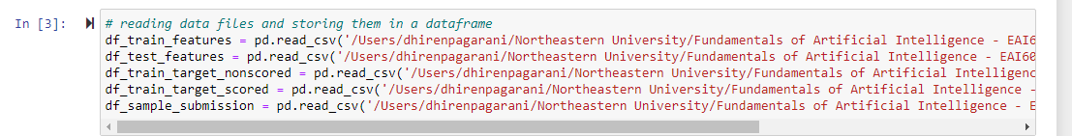

Following is the logic for defining the seeds

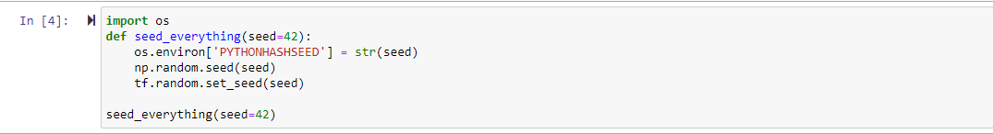

Following is the check for verifying the training and testing datasets size:



For building the model we decided to copy the data frame rather than modifying the dataset in order to feed the model with it and here is the logic for the same:

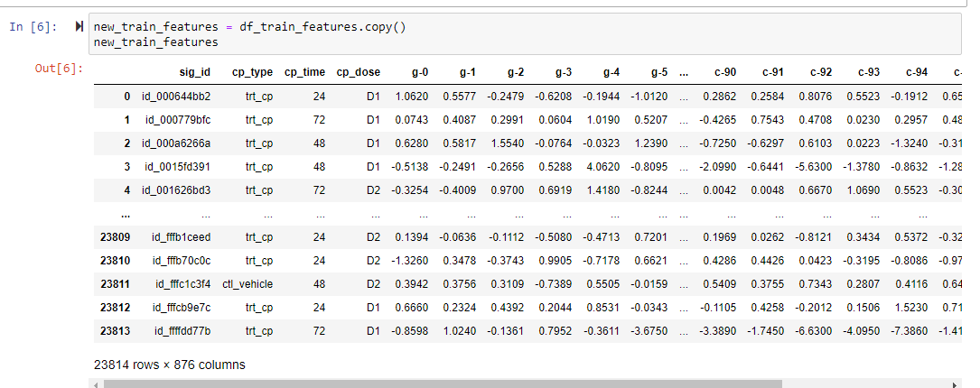

Now pre processing the dataset:

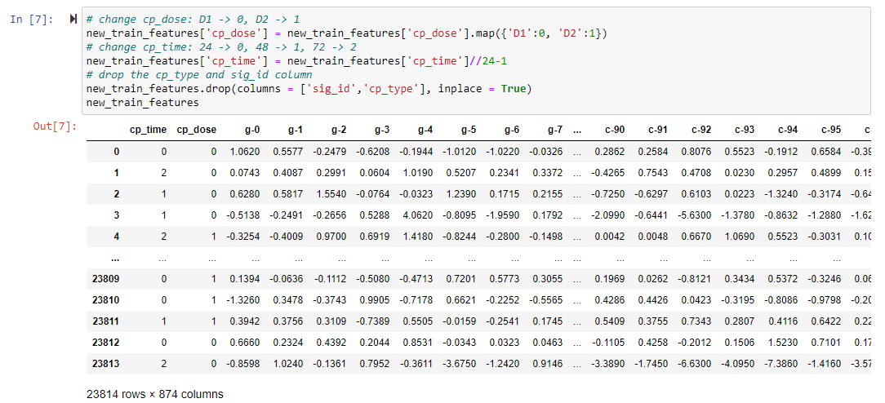

Copying the target scored dataset and then processing the target scored dataset:

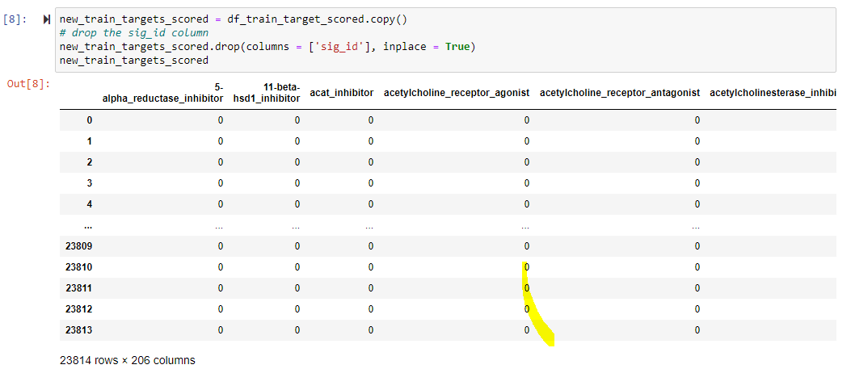

Storing the data into X and y variables in order to read target variables and label values.

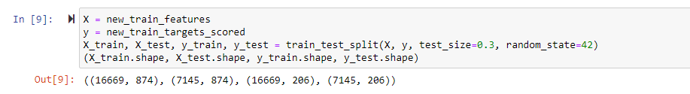

Now we have to build a model and here is the logic for the same: We decided to use early stopping callback approach as we were not getting good results with other approaches and then build sequential model on top of it with 3 layers on top of sigmoid layer. Compiling it using adam optimizer and ‘binary cross entropy’ loss.

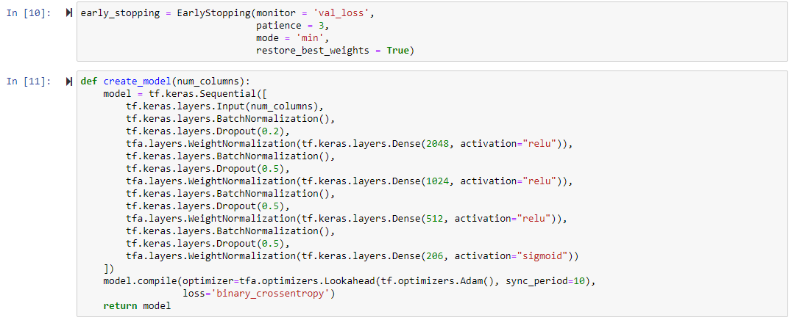

Now we will finally build the model and fit it one the dataset for epoch count 35.

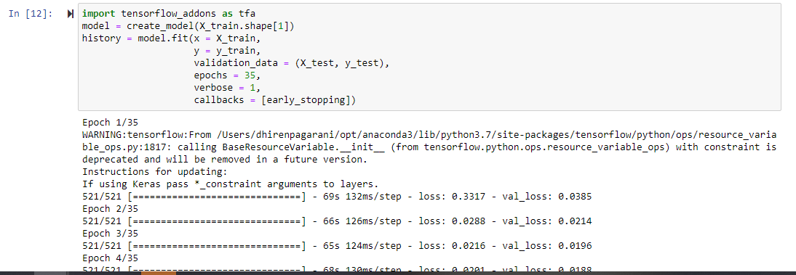

Here is the summary of our model:

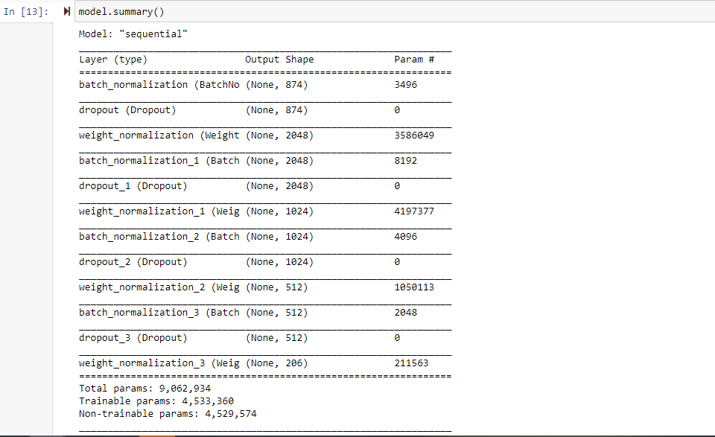

Here is the visualization we did for our model for displaying validation loss and training loss

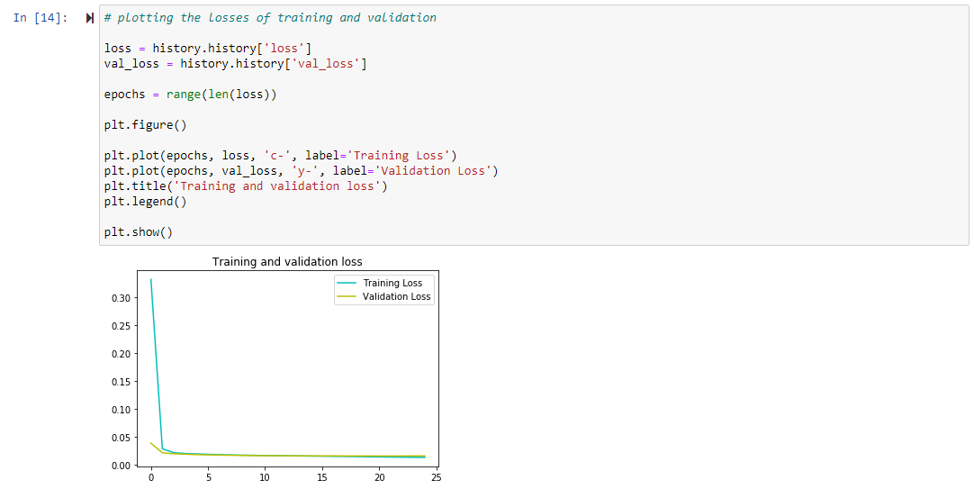

Now before making predictions we will again make copy of test dataset and do the pre processing before feeding it into the model:

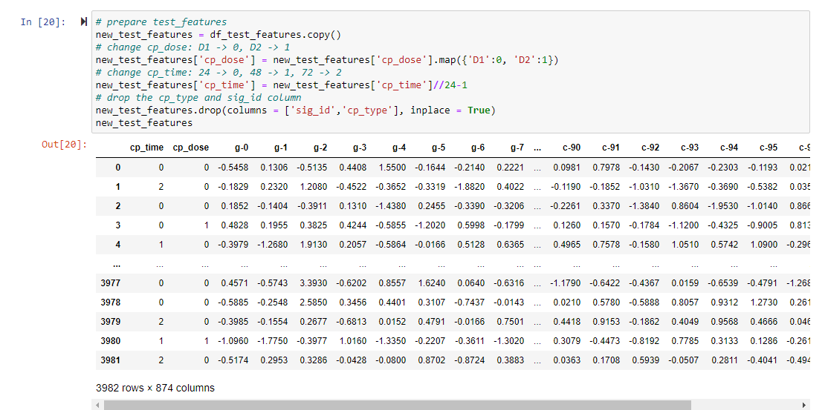

Now finally making predictions :

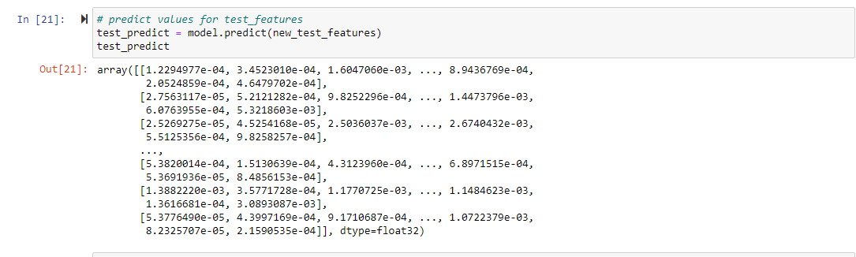

**Conclusion**

Finally, here is the predicted file that we received in the form of probabilities and the results are pretty good as compared to previously build algorithms.

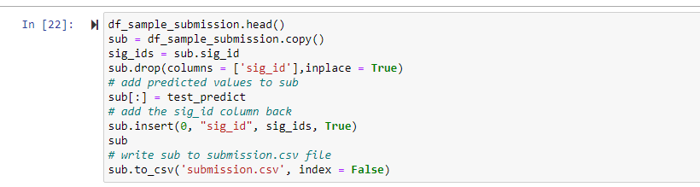

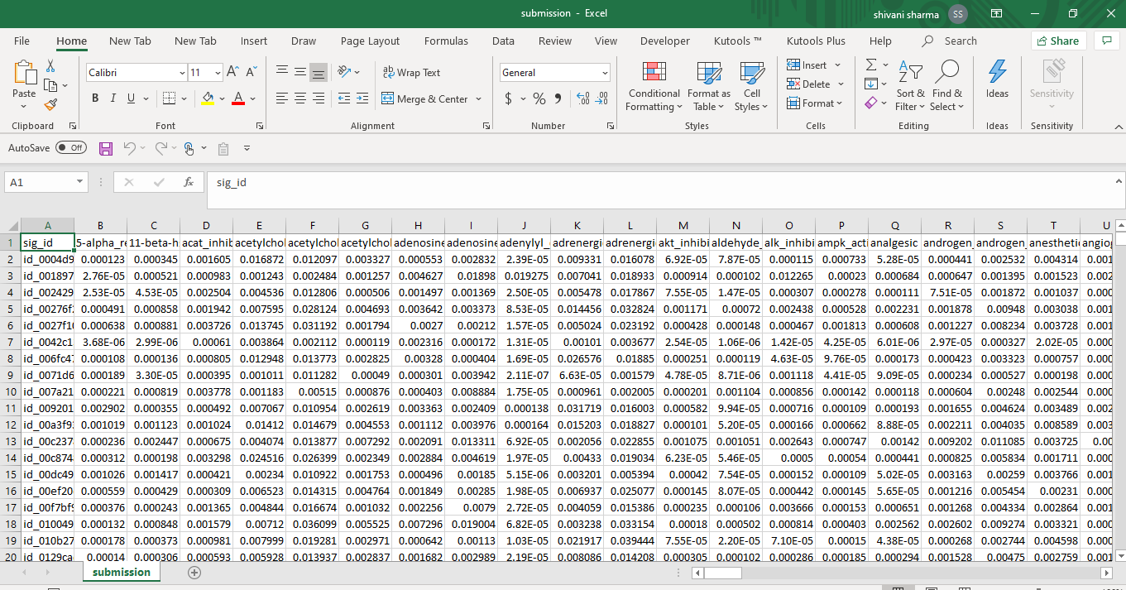

**Reference**

1. Missinglink.ai, (n.d), Neural Networks for Regression (Part 1)—Overkill or Opportunity? Retrieved from

<https://missinglink.ai/guides/neural-network-concepts/neural-networks-regression-part-1-overkill-opportunity/#:~:text=Regression%20in%20Neural%20Networks,equivalent%20to%20a%20logistic%20regression>.

1. Packt, (n.d), Pros and cons of neural networks, Retrieved from

<https://subscription.packtpub.com/book/big_data_and_business_intelligence/9781788397872/1/ch01lvl1sec27/pros-and-cons-of-neural-networks>

1. Brownlee, J. (2020, September 15). Your First Deep Learning Project in Python with Keras Step-By-Step. Retrieved November 23, 2020, from https://machinelearningmastery.com/tutorial-first-neural-network-python-keras/